

Chiropractic Board of Australia

Registrant data

Reporting period: 1 October 2018 – 31 December 2018

Table of contents
Introduction 3
Principal place of practice 4
1. Registration type 4
2. Endorsements by type 4
Age group 5
3. Registration type and subtype 5
Gender 6
4. Registration type 6
5. Percentage 6

Introduction
The functions of the Chiropractic Board of Australia (the Board) include:
- registering chiropractors and students
- developing standards, codes and guidelines for the chiropractic profession
- handling notifications, complaints, investigations and disciplinary hearings
- overseeing the assessment of overseas trained practitioners who wish to practise in Australia, and
- approving accreditation standards and accredited courses of study.
The Board’s functions are supported by the Australian Health Practitioner Regulation Agency (AHPRA). For information about legislation governing our operations see AHPRA's Legislation & Publications at www.ahpra.gov.au/Publications
The Board has analysed its registration data and produced a number of statistical breakdowns about registrants to share with the profession and community. The Board shares these breakdowns regularly.
For more information on chiropractor registration, please see the Board’s website: www.chiropracticboard.gov.au/Registration.aspx

Principal place of practice
- Registration type
  - Registration type by principal place of practice
Registration type | ACT | NSW | NT | QLD | SA | TAS | VIC | WA | No PPP | Total
General | 70 | 1,738 | 26 | 848 | 364 | 53 | 1,386 | 622 | 73 | 5,180
Limited (Public Interest) |  |  |  |  |  |  |  |  | 1 | 1
Non-practising | 3 | 86 | 1 | 30 | 15 | 2 | 79 | 19 | 106 | 341
Total | 73 | 1,824 | 27 | 878 | 379 | 55 | 1,465 | 641 | 180 | 5,522

  - Principal place of practice percentages

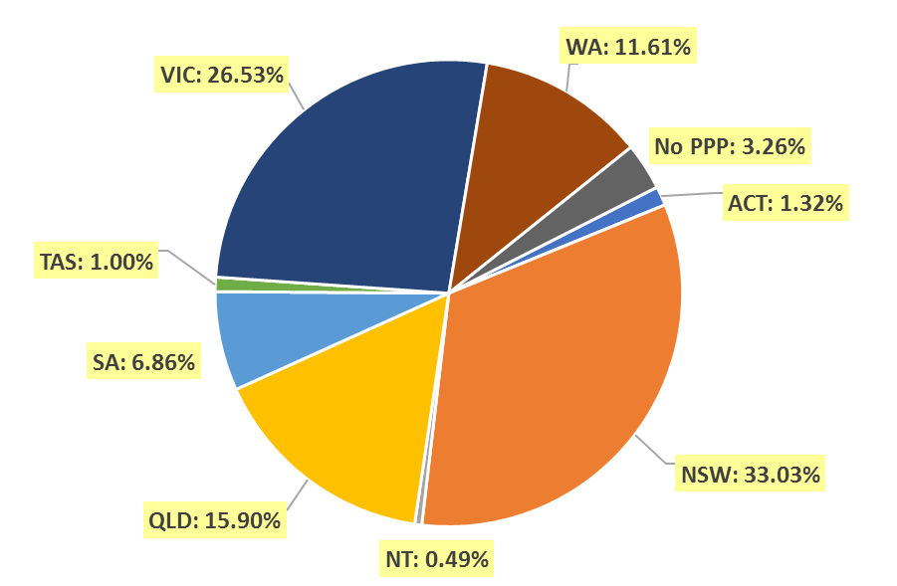

- Endorsements by type
  - Endorsements
Endorsement | ACT | NSW | NT | QLD | SA | TAS | VIC | WA | No PPP | Total
Acupuncture |  |  |  |  |  |  | 30 |  |  | 30

Age group
- Registration type and subtype
  - Registration by age group
Age group | General | Limited (Public Interest) | Non-practising | Total
U - 25 | 165 |  |  | 165
25 - 29 | 692 |  | 44 | 736
30 - 34 | 866 |  | 66 | 932
35 - 39 | 752 |  | 46 | 798
40 - 44 | 709 |  | 51 | 760
45 - 49 | 666 |  | 37 | 703
50 - 54 | 399 | 1 | 23 | 423
55 - 59 | 387 |  | 24 | 411
60 - 64 | 239 |  | 17 | 256
65 - 69 | 167 |  | 17 | 184
70 - 74 | 88 |  | 8 | 96
75 - 79 | 30 |  | 6 | 36
80+ | 20 |  | 2 | 22
Total | 5,180 | 1 | 341 | 5,522

  - Registrants by age group

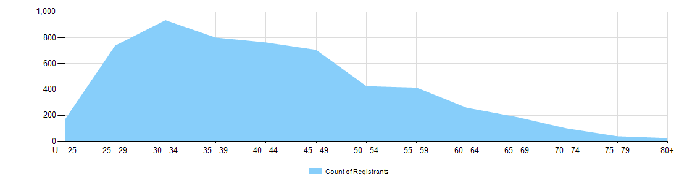
Gender
- Registration type
  - Registration type by gender
Gender | Registration Type | ACT | NSW | NT | QLD | SA | TAS | VIC | WA | No PPP | Total
Female | General | 33 | 636 | 6 | 310 | 133 | 17 | 605 | 272 | 28 | 2,040
Female | Non-practising | 3 | 44 | 1 | 12 | 7 | 1 | 41 | 6 | 44 | 159
Total female |  | 36 | 680 | 7 | 322 | 140 | 18 | 646 | 278 | 72 | 2,199
Male | General | 37 | 1,102 | 20 | 538 | 231 | 36 | 781 | 350 | 45 | 3,140
Male | Limited (public interest) |  |  |  |  |  |  |  |  | 1 | 1
Male | Non-practising |  | 42 |  | 18 | 8 | 1 | 38 | 13 | 62 | 182
Total male |  | 37 | 1,144 | 20 | 556 | 239 | 37 | 819 | 363 | 108 | 3,323
Total |  | 73 | 1,824 | 27 | 878 | 379 | 55 | 1,465 | 641 | 180 | 5,522

- Percentage
  - Registration by gender percentages
Gender | ACT | NSW | NT | QLD | SA | TAS | VIC | WA | No PPP | Total
Female | 49.3% | 37.3% | 25.9% | 36.7% | 36.9% | 32.7% | 44.1% | 43.4% | 40.0% | 39.8%
Male | 50.7% | 62.7% | 74.1% | 63.3% | 63.1% | 67.3% | 55.9% | 56.6% | 60.0% | 60.2%

