

Chiropractic Board of Australia

Registrant data

Reporting period: 1 July 2018 – 30 September 2018

Table of contents
Introduction 3
Principal place of practice 4
1. Registration type 4
2. Endorsements by type 4
Age group 5
3. Registration type and subtype 5
Gender 6
4. Registration type 6
5. Percentage 6

Introduction
The functions of the Chiropractic Board of Australia (the Board) include:
- registering chiropractors and students
- developing standards, codes and guidelines for the chiropractic profession
- handling notifications, complaints, investigations and disciplinary hearings
- overseeing the assessment of overseas trained practitioners who wish to practise in Australia, and
- approving accreditation standards and accredited courses of study.
The Board’s functions are supported by the Australian Health Practitioner Regulation Agency (AHPRA). For information about legislation governing our operations see AHPRA's Legislation & Publications at www.ahpra.gov.au/Publications
The Board has analysed its registration data and produced a number of statistical breakdowns about registrants to share with the profession and community. The Board shares these breakdowns regularly.
For more information on chiropractor registration, please see the Board’s website: www.chiropracticboard.gov.au/Registration.aspx

Principal place of practice
- Registration type
  - Registration type by principal place of practice
Registration type | ACT | NSW | NT | QLD | SA | TAS | VIC | WA | No PPP | Total
General | 67 | 1,729 | 26 | 831 | 357 | 49 | 1,343 | 626 | 63 | 5,091
Limited (Public Interest) |  |  |  |  |  |  |  |  | 1 | 1
Non-practising | 3 | 86 | 1 | 33 | 13 | 3 | 73 | 19 | 102 | 333
Total | 70 | 1,815 | 27 | 864 | 370 | 52 | 1,416 | 645 | 166 | 5,425

  - Principal place of practice percentages

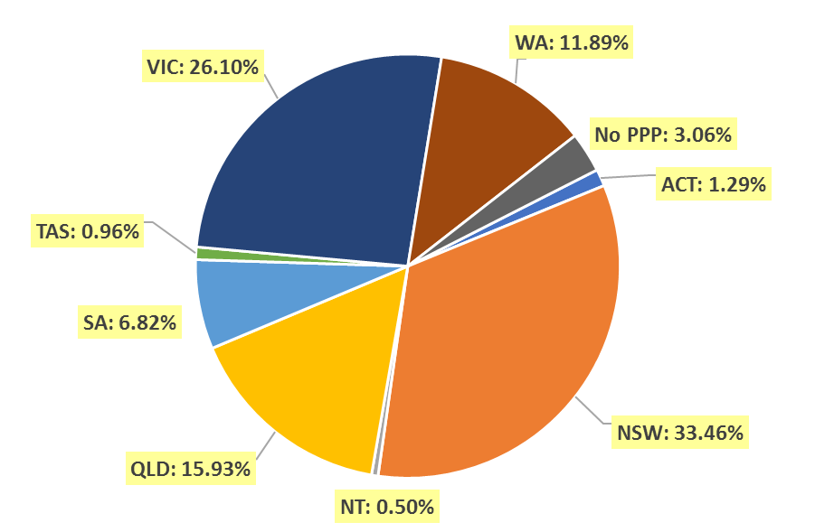

- Endorsements by type
  - Endorsements
Endorsement | ACT | NSW | NT | QLD | SA | TAS | VIC | WA | No PPP | Total
Acupuncture |  |  |  |  |  |  | 30 |  |  | 30

Age group
- Registration type and subtype
  - Registration by age group
Age group | General | Limited (Public Interest) | Non-practising | Total
U - 25 | 134 |  |  | 134
25 - 29 | 690 |  | 43 | 733
30 - 34 | 856 |  | 62 | 918
35 - 39 | 750 |  | 43 | 793
40 - 44 | 699 | 1 | 54 | 754
45 - 49 | 656 |  | 36 | 692
50 - 54 | 399 |  | 22 | 421
55 - 59 | 380 |  | 23 | 403
60 - 64 | 227 |  | 18 | 245
65 - 69 | 172 |  | 17 | 189
70 - 74 | 80 |  | 8 | 88
75 - 79 | 29 |  | 5 | 34
80+ | 19 |  | 2 | 21
Total | 5,091 | 1 | 333 | 5,425

  - Registrants by age group

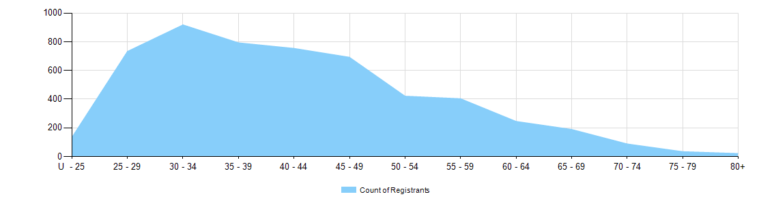
Gender
- Registration type
  - Registration type by gender
Gender | Registration Type | ACT | NSW | NT | QLD | SA | TAS | VIC | WA | No PPP | Total
Female | General | 30 | 633 | 7 | 307 | 132 | 15 | 574 | 276 | 20 | 1,994
Female | Non-practising | 3 | 45 | 1 | 12 | 7 | 2 | 38 | 7 | 42 | 157
Total female |  | 33 | 678 | 8 | 319 | 139 | 17 | 612 | 283 | 62 | 2,151
Male | General | 37 | 1,096 | 19 | 524 | 225 | 34 | 769 | 350 | 43 | 3,097
Male | Limited (public interest) |  |  |  |  |  |  |  |  | 1 | 1
Male | Non-practising |  | 41 |  | 21 | 6 | 1 | 35 | 12 | 60 | 176
Total male |  | 37 | 1,137 | 19 | 545 | 231 | 35 | 804 | 362 | 104 | 3,274
Total |  | 70 | 1,815 | 27 | 864 | 370 | 52 | 1,416 | 645 | 166 | 5,425

- Percentage
  - Registration by gender percentages
Gender | ACT | NSW | NT | QLD | SA | TAS | VIC | WA | No PPP | Total
Female | 47.1% | 37.4% | 29.6% | 36.9% | 37.6% | 32.7% | 43.2% | 43.9% | 37.3% | 39.6%
Male | 52.9% | 62.6% | 70.4% | 63.1% | 62.4% | 67.3% | 56.8% | 56.1% | 62.7% | 60.4%

