

Chiropractic Board of Australia

Registrant Data

Reporting period: 1 October 2016 – 31 December 2016

Table of contents
Introduction 3
Principal Place of Practice 4
1. Registration Type 4
2. Endorsements by Type 4
Age Group 5
3. Registration Type and Sub type 5
Gender 6
4. Registration Type 6
5. Percentage 6

Introduction
The functions of the Chiropractic Board of Australia (the Board) include:
- registering chiropractors and students
- developing standards, codes and guidelines for the chiropractic profession
- handling notifications, complaints, investigations and disciplinary hearings
- overseeing the assessment of overseas trained practitioners who wish to practise in Australia, and
- approving accreditation standards and accredited courses of study.
The Board’s functions are supported by the Australian Health Practitioner Regulation Agency (AHPRA). For information about legislation governing our operations see AHPRA's Legislation & Publications at www.ahpra.gov.au/Publications
The Board has analysed its registration data and produced a number of statistical breakdowns about registrants to share with the profession and community. The Board shares these breakdowns regularly.
For more information on chiropractor registration, please see the Board’s website: http://www.chiropracticboard.gov.au/Registration.aspx

Principal Place of Practice
- Registration Type
  - Registration type by principal place of practice
Registration Type | ACT | NSW | NT | QLD | SA | TAS | VIC | WA | No PPP | Total
General | 64 | 1,689 | 26 | 812 | 358 | 55 | 1,287 | 595 | 75 | 4,961
Limited (Public Interest) |  |  |  | 2 |  |  |  |  |  | 2
Non-practising | 2 | 71 | 2 | 30 | 17 | 2 | 71 | 23 | 96 | 314
Total | 66 | 1,760 | 28 | 844 | 375 | 57 | 1,358 | 618 | 171 | 5,277

  - Registration Type by Principal Place of Practice Percentages

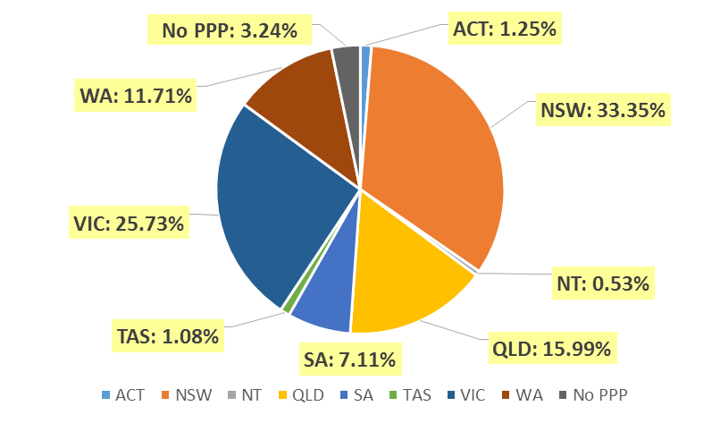

- Endorsements by Type
  - Endorsements
Endorsement | ACT | NSW | NT | QLD | SA | TAS | VIC | WA | No PPP | Total
Acupuncture |  |  |  |  |  |  | 32 |  |  | 32

Age Group
- Registration Type and Sub type
  - Registration by age group
Age Group | General | Limited (Public Interest) | Non-practising | Total
U - 25 | 122 |  | 1 | 123
25 - 29 | 802 |  | 38 | 840
30 - 34 | 803 |  | 56 | 859
35 - 39 | 695 | 2 | 58 | 755
40 - 44 | 722 |  | 36 | 758
45 - 49 | 572 |  | 27 | 599
50 - 54 | 397 |  | 27 | 424
55 - 59 | 345 |  | 21 | 366
60 - 64 | 229 |  | 17 | 246
65 - 69 | 149 |  | 14 | 163
70 - 74 | 78 |  | 8 | 86
75 - 79 | 34 |  | 9 | 43
80+ | 13 |  | 2 | 15
Total | 4,961 | 2 | 314 | 5,277

  - Registrants by age group
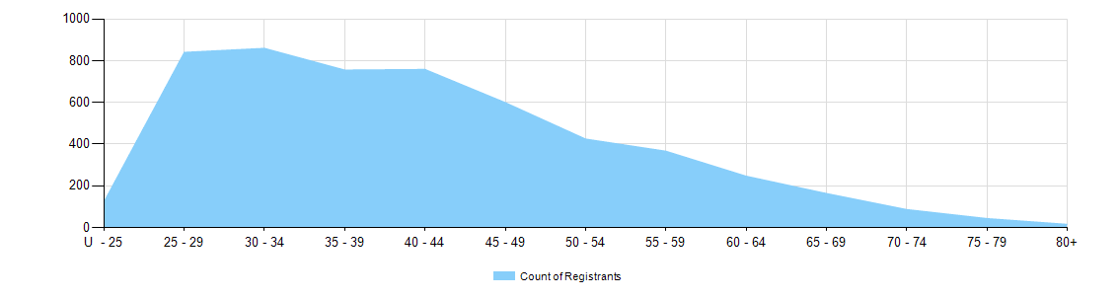

Gender
- Registration Type
  - Registration type by gender
Gender | Registration Type | ACT | NSW | NT | QLD | SA | TAS | VIC | WA | No PPP | Total
Female | General | 30 | 612 | 8 | 285 | 134 | 17 | 528 | 256 | 30 | 1,900
Female | Non-practising | 2 | 38 | 2 | 11 | 8 | 1 | 38 | 11 | 35 | 146
Female | Limited (Public Interest) |  |  |  | 1 |  |  |  |  |  | 1
Total Female |  | 32 | 650 | 10 | 297 | 142 | 18 | 566 | 267 | 65 | 2,047
Male | General | 34 | 1,077 | 18 | 527 | 224 | 38 | 759 | 339 | 45 | 3,061
Male | Non-practising |  | 33 |  | 19 | 9 | 1 | 33 | 12 | 61 | 168
Male | Limited (Public Interest) |  |  |  | 1 |  |  |  |  |  | 1
Total Male |  | 34 | 1,110 | 18 | 547 | 233 | 39 | 792 | 351 | 106 | 3,230
Total |  | 66 | 1,760 | 28 | 844 | 375 | 57 | 1,358 | 618 | 171 | 5,277

- Percentage
  - Registration by gender percentages
Gender | ACT | NSW | NT | QLD | SA | TAS | VIC | WA | No PPP | Total
Female | 48.5% | 36.9% | 35.7% | 35.2% | 37.9% | 31.6% | 41.7% | 43.2% | 38% | 38.8%
Male | 51.5% | 63.1% | 64.3% | 64.8% | 62.1% | 68.4% | 58.3% | 56.8% | 62% | 61.2%

