

Chiropractic Board of Australia

Registrant data

Reporting period: 1 October 2017 – 31 December 2017

Table of contents
Introduction 3
Principal place of practice 4
1. Registration type 4
2. Endorsements by type 4
Age group 5
3. Registration type and subtype 5
Gender 6
4. Registration type 6
5. Percentage 6

Introduction
The functions of the Chiropractic Board of Australia (the Board) include:
- registering chiropractors and students
- developing standards, codes and guidelines for the chiropractic profession
- handling notifications, complaints, investigations and disciplinary hearings
- overseeing the assessment of overseas trained practitioners who wish to practise in Australia, and
- approving accreditation standards and accredited courses of study.
The Board’s functions are supported by the Australian Health Practitioner Regulation Agency (AHPRA). For information about legislation governing our operations see AHPRA's Legislation & Publications at www.ahpra.gov.au/Publications
The Board has analysed its registration data and produced a number of statistical breakdowns about registrants to share with the profession and community. The Board shares these breakdowns regularly.
For more information on chiropractor registration, please see the Board’s website: www.chiropracticboard.gov.au/Registration.aspx

Principal place of practice
- Registration type
  - Registration type by principal place of practice
Registration type | ACT | NSW | NT | QLD | SA | TAS | VIC | WA | No PPP | Total
General | 66 | 1,706 | 26 | 817 | 355 | 52 | 1,318 | 603 | 60 | 5,003
Limited (Public Interest) |  |  |  | 2 |  |  |  |  |  | 2
Non-practising | 3 | 91 | 2 | 37 | 18 | 2 | 79 | 21 | 106 | 359
Total | 69 | 1,797 | 28 | 856 | 373 | 54 | 1,397 | 624 | 166 | 5,364

  - Registration type by principal place of practice percentages
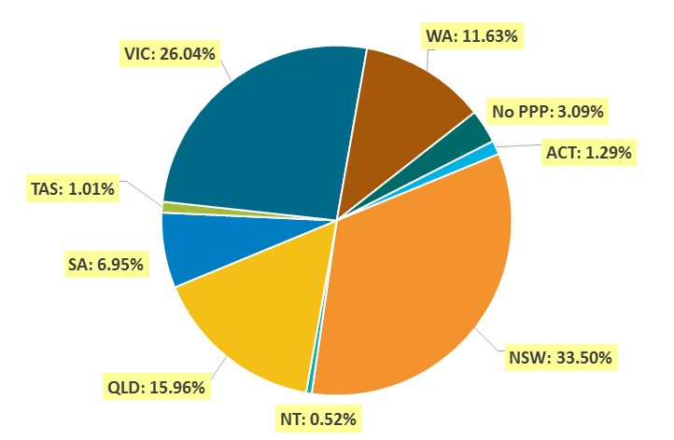

- Endorsements by type
  - Endorsements
Endorsement | ACT | NSW | NT | QLD | SA | TAS | VIC | WA | No PPP | Total
Acupuncture |  |  |  |  |  |  | 31 |  |  | 31

Age group
- Registration type and subtype
  - Registration by age group
Age group | General | Limited (Public Interest) | Non-practising | Total
U - 25 | 121 |  | 3 | 124
25 - 29 | 745 |  | 48 | 793
30 - 34 | 807 |  | 70 | 877
35 - 39 | 733 | 1 | 49 | 783
40 - 44 | 703 | 1 | 48 | 752
45 - 49 | 633 |  | 34 | 667
50 - 54 | 393 |  | 28 | 421
55 - 59 | 364 |  | 23 | 387
60 - 64 | 219 |  | 21 | 240
65 - 69 | 165 |  | 15 | 180
70 - 74 | 71 |  | 8 | 79
75 - 79 | 32 |  | 9 | 41
80+ | 17 |  | 3 | 20
Total | 5,003 | 2 | 359 | 5,364

  - Registrants by age group
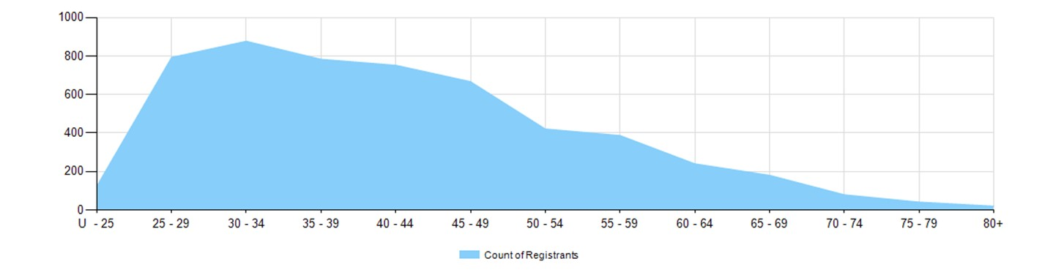
Gender
- Registration type
  - Registration type by gender
Gender | Registration Type | ACT | NSW | NT | QLD | SA | TAS | VIC | WA | No PPP | Total
Female | General | 30 | 619 | 8 | 296 | 132 | 16 | 557 | 259 | 18 | 1,935
Female | Limited (public interest) |  |  |  | 1 |  |  |  |  |  | 1
Female | Non-practising | 3 | 50 | 2 | 13 | 9 | 1 | 43 | 10 | 42 | 173
Total female |  | 33 | 669 | 10 | 310 | 141 | 17 | 600 | 269 | 60 | 2109
Male | General | 36 | 1,087 | 18 | 521 | 223 | 36 | 761 | 344 | 42 | 3,068
Male | Limited (public interest) |  |  |  | 1 |  |  |  |  |  | 1
Male | Non-practising |  | 41 |  | 24 | 9 | 1 | 36 | 11 | 64 | 186
Total male |  | 36 | 1,128 | 18 | 546 | 232 | 37 | 797 | 355 | 106 | 3255
Total |  | 69 | 1,797 | 28 | 856 | 373 | 54 | 1,397 | 624 | 166 | 5,364

- Percentage
  - Registration by gender percentages
Gender | ACT | NSW | NT | QLD | SA | TAS | VIC | WA | No PPP | Total
Female | 47.8% | 37.2% | 35.7% | 36.2% | 37.8% | 31.5% | 42.9% | 43.1% | 36.1% | 39.3%
Male | 52.2% | 62.8% | 64.3% | 63.8% | 62.2% | 68.5% | 57.1% | 56.9% | 63.9% | 60.7%

