

Chiropractic Board of Australia

Registrant data

Reporting period: 1 January 2018 – 31 March 2018

Table of contents
Introduction 3
Principal place of practice 4
1. Registration type 4
2. Endorsements by type 4
Age group 5
3. Registration type and subtype 5
Gender 6
4. Registration type 6
5. Percentage 6

Introduction
The functions of the Chiropractic Board of Australia (the Board) include:
- registering chiropractors and students
- developing standards, codes and guidelines for the chiropractic profession
- handling notifications, complaints, investigations and disciplinary hearings
- overseeing the assessment of overseas trained practitioners who wish to practise in Australia, and
- approving accreditation standards and accredited courses of study.
The Board’s functions are supported by the Australian Health Practitioner Regulation Agency (AHPRA). For information about legislation governing our operations see AHPRA's Legislation & Publications at www.ahpra.gov.au/Publications
The Board has analysed its registration data and produced a number of statistical breakdowns about registrants to share with the profession and community. The Board shares these breakdowns regularly.
For more information on chiropractor registration, please see the Board’s website: www.chiropracticboard.gov.au/Registration.aspx

Principal place of practice
- Registration type
  - Registration type by principal place of practice
Registration type | ACT | NSW | NT | QLD | SA | TAS | VIC | WA | No PPP | Total
General | 66 | 1,730 | 26 | 825 | 356 | 48 | 1,340 | 623 | 58 | 5,072
Limited (Public Interest) |  |  |  |  |  |  |  |  | 1 | 1
Non-practising | 3 | 83 | 1 | 33 | 14 | 2 | 76 | 21 | 103 | 336
Total | 69 | 1,813 | 27 | 858 | 370 | 50 | 1,416 | 644 | 162 | 5,409

  - Principal place of practice percentages

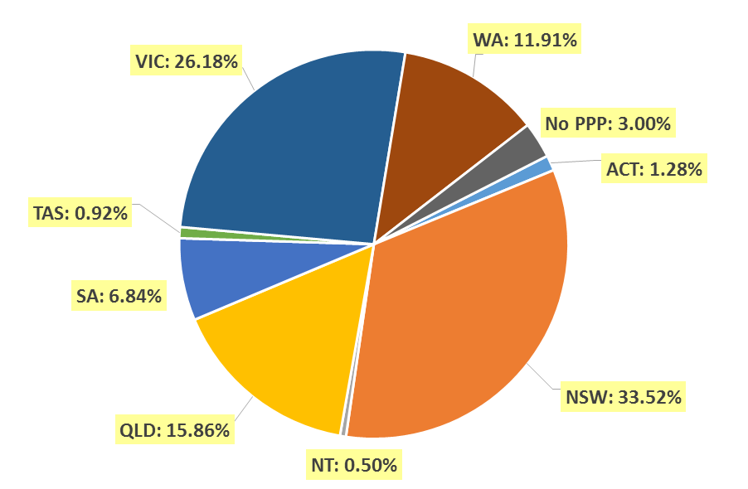

- Endorsements by type
  - Endorsements
Endorsement | ACT | NSW | NT | QLD | SA | TAS | VIC | WA | No PPP | Total
Acupuncture |  |  |  |  |  |  | 30 |  |  | 30

Age group
- Registration type and subtype
  - Registration by age group
Age group | General | Limited (Public Interest) | Non-practising | Total
U - 25 | 184 |  | 2 | 186
25 - 29 | 738 |  | 51 | 789
30 - 34 | 819 |  | 59 | 878
35 - 39 | 733 |  | 50 | 783
40 - 44 | 698 | 1 | 48 | 747
45 - 49 | 645 |  | 32 | 677
50 - 54 | 387 |  | 24 | 411
55 - 59 | 368 |  | 23 | 391
60 - 64 | 218 |  | 18 | 236
65 - 69 | 163 |  | 14 | 177
70 - 74 | 72 |  | 8 | 80
75 - 79 | 30 |  | 6 | 36
80+ | 17 |  | 1 | 18
Total | 5,072 | 1 | 336 | 5,409

  - Registrants by age group

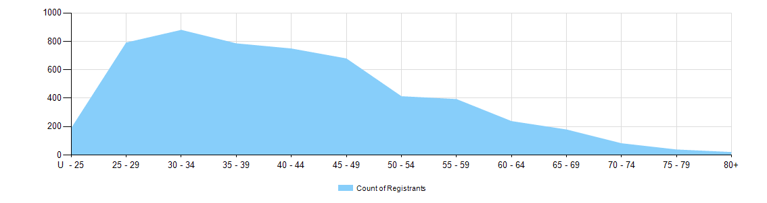
Gender
- Registration type
  - Registration type by gender
Gender | Registration Type | ACT | NSW | NT | QLD | SA | TAS | VIC | WA | No PPP | Total
Female | General | 30 | 632 | 7 | 303 | 132 | 14 | 572 | 275 | 17 | 1,982
Female | Limited (public interest)
Female | Non-practising | 3 | 43 | 1 | 12 | 8 | 1 | 40 | 9 | 42 | 159
Total female |  | 33 | 675 | 8 | 315 | 140 | 15 | 612 | 284 | 59 | 2,141
Male | General | 36 | 1,098 | 19 | 522 | 224 | 34 | 768 | 348 | 41 | 3,090
Male | Limited (public interest) |  |  |  |  |  |  |  |  | 1 | 1
Male | Non-practising |  | 40 |  | 21 | 6 | 1 | 36 | 12 | 61 | 177
Total male |  | 36 | 1,138 | 19 | 543 | 230 | 35 | 804 | 360 | 103 | 3,268
Total |  | 69 | 1,813 | 27 | 858 | 370 | 50 | 1,416 | 644 | 162 | 5,409

- Percentage
  - Registration by gender percentages
Gender | ACT | NSW | NT | QLD | SA | TAS | VIC | WA | No PPP | Total
Female | 47.8% | 37.2% | 29.6% | 36.7% | 37.8% | 30.0% | 43.2% | 44.1% | 36.4% | 39.6%
Male | 52.2% | 62.8% | 70.4% | 63.3% | 62.2% | 70.0% | 56.8% | 55.9% | 63.6% | 60.4%

